All Creation Worships Me
April 5th, 2017

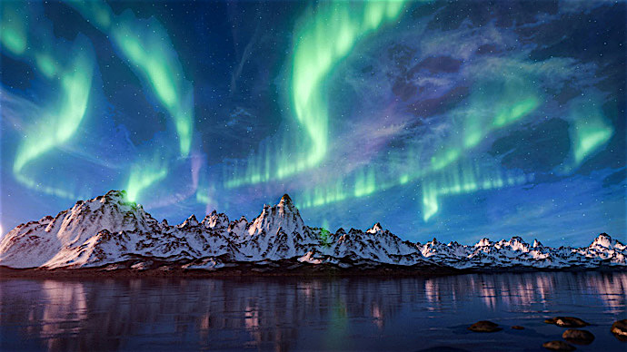
This is a continuation of yesterday's message, Deeper Intimacy with God. But here the Lord is talking about His relationship with Creation. Very, very beautiful. Very beautiful message.

And then He started bringing up some Scriptures:

"Is it not written: The heavens declare the glory of God; the skies proclaim the work of his hands. Psalm 19:1

"And how do they declare the glory of God? They worship Me. Have you not heard the stars singing to Me? Now science is beginning to understand there is a sound vibration connected to all creatures and within that vibration they are worshipping Me."

But ask the animals, and they will teach you, or the birds in the sky, and they will tell you; or speak to the earth, and it will teach you, or let the fish in the sea inform you.
Which of all these does not know that the hand of the LORD has done this? In his hand is the life of every creature and the breath of all mankind.
Job 12:7-10

Let the heavens rejoice, let the earth be glad; let the sea resound, and all that is in it. Let the fields be jubilant, and everything in them; let all the trees of the forest sing for joy. Psalm 96:11-12

'Let the Heavens rejoice.' Rejoicing is not a passive thing, like stars just floating in space, twinkling. Doing nothing but reflecting light. Rejoicing is an expression of worship coming from the stars He created. The Lord is present in all Creation and it makes perfect sense that the life-force flowing through them, holding them in the created universe, would worship God. Rejoicing at their very being.

Jesus continued, "'Let the Earth be glad.' How can the Earth be glad if it has no soul and no emotion? 'Let the sea resound and all that's in it.' How can the sea do this if it has no soul, and has no ability to worship Me? 'Let the fields be jubilant and everything in them. Let all the trees of the forest sing for joy.' How can this happen if there is no soul? If there is not worship coming forth from them?"

That's written in Genesis 9:1, by the way. Also, in Genesis 9:12. And God said, This is the sign of the covenant I am making between Me and you and every living creature with you. A covenant for all generations.

"Obviously, you cannot make a covenant with an inanimate object. The fact is, when you come to be with Me in Heaven you will see the souls of the Earth, the souls of the flowers, the fish, the birds, the trees. You will see how they worship Me."

The wild animals honor me, the jackals and the owls, because I provide water in the wilderness and streams in the wasteland, to give drink to my people, my chosen, wild animals honor Me. Isaiah 43:20

"All creatures rejoice in My goodness and love for them. And at the end of their lives, they come to Heaven to live with Me forever in a creation that never decays, and is in a constant state of worship. They also mourn and pine away for My coming, because they have their own way of understanding the devastating blow that's given to them through Satan's cruel hatred, as he lashes out at Me by destroying the live I created."

And here, I'd like to draw our attention to the Scriptures that confirm what the Lord is saying, for the sake of those who might think that this is a novel teaching, not from Jesus. All things are made for God and sustained in and by God. So there is nothing usual about all Creation worshipping Him.

Even as it's written here in Isaiah 49:13
Shout for joy, O heavens! And rejoice, O earth! Break forth into joyful shouting, O mountains! For the LORD has comforted His people, And will have compassion on His afflicted.

And Psalm 96:11 Let the heavens be glad, and let the earth rejoice; And let them say among the nations, "The LORD reigns.

So here He's exhorting the Heavens and the Earth to rejoice and to say among the nations, the Lord reigns!

In John 1:1 In the beginning was the Word, and the Word was with God, and the Word was God. ...3All things were made by him; and without him was not any thing made that was made.

And later on it talks again about the Word in Hebrews 1:3
The Son is the radiance of God’s glory and the exact representation of His nature, upholding all things by His powerful word.

In the beginning was the Word, and the Word was with God, and the Word was God. All things were made by him.

And Colossians 1:16
In Him all things were created, things in heaven and on earth, visible and invisible, whether thrones or dominions or rulers or authorities. All things were created through Him and for Him.

So this alludes to the fact that the Lord wants to fellowship with Creation. Why would He make something that He could not fellowship with? That doesn't make any sense. There's a continual interaction going back and forth in the way of worship. Worship, and I am sure, complaints! Complaints about what Satan is doing to the Earth through man.

Proverbs 16:4 The LORD has made all things for himself.

1 Corinthians 8:6 And there is but one Lord, Jesus Christ, through whom all things came and through whom we exist.

And that again points to the fact that we exist, this by the continuing act of His will and His word - His living word. We continue to exist in Him and through Him. And that means Creation exists through Him as well. So, it makes total sense that the Creation would worship Him.

Ephesians 4:4-6 There is one body and one Spirit, just as you were called to one hope when you were called; one Lord, one faith, one baptism; one God and Father of all, who is over all and through all and in all.

Those aren't idle word, guys. The Lord does exist through His Creation. We don't worship His creation, we worship Him. But His Creation is a brother or a sister to us, because we're also created. Although we supposedly have a higher mentality, the ability to think, Creation conforms itself to Him much better than we do. But Creation can also be made to rebel against God through the influence of Satan.

And finally in Hebrews 1:3 The Son is the radiance of God's glory and the exact representation of His nature, upholding all things by his powerful word.

"All things" means all things. It means us and all of Creation are continually being upheld by His word, His continuing word. And if He revoked His word, we would all be destroyed instantly.

So, again it makes complete sense that Creation would reflect back to God the glory and awesomeness of His nature, in worship of Him. And it is confirmed here in the Scriptures.

So, we have several witnesses here. We have Isaiah, the prophet Isaiah witnessing to it. David, in Psalms. John the Apostle and Paul in Colossians, the Corinthians, Ephesians and Hebrews.

So, through all these witnesses we can rest assured that God created Creation and that He does have a relationship with Creation, whereby His creatures worship Him. Just because we can't understand it, and we can't translate it. We don't know it - doesn't mean it doesn't exist. The Scriptures say it DOES exist. So, we can rest, because it's in the Scriptures. For anyone who has questions, I hope this clarifies it for you. I hope it clears it up. I know I certainly did when I was told these things. We are all in this together.

Thank you, Lord, for Your word.

Here again I'm quoting from Scripture:
We know that the whole creation has been groaning together in the pains of childbirth until the present time. Not only so, but we ourselves, who have the first fruits of the Spirit, groan inwardly as we wait eagerly for our adoption as sons, the redemption of our bodies.
Romans 8:22-23

Here, He's talking about the Rapture. And that all Creation is groaning in anticipation of My coming.

He continued, "So you see, it is written, yet men think they have Me figured out and the life force of Creation has no understanding. How far from the truth this is! I created all with a choice to worship or despise Me, even as they choose to love or reject a man. When Creation receives man, or woman, or a child - it responds in love. Though you cannot normally perceive this consciousness, it still exists.

"When an animal rejects a human, it is showing its attitude towards that person. This is a free will choice on the part of the animal, not only a result of their conditioning and history with a human. They can come from a very loving family, but not like someone when they walk in the door. You have seen this response in dogs.

"There is so much that is not known about the nature of My relationship with Creation. That includes you, My dear. I do need your affection and your worship, so please return to Me now."

So, at that point, I came back to prayer. And it was still somewhat sweet, but something really had been lost. There was a deeper communion going on before I got up, got sidetracked by the refrigerator. When I tell you that He couldn't find a worse example than myself, you can see by these examples He's speaking the truth. That's not just a figure of speech.

So, the Lord bless you, dear ones. And don't be foolish like I was! Stay close to Him. When that time is really sweet, don't let anything pull you out of it. If you have to use the restroom or do something, do it quickly, and come right back. Be aware that the minute you get up, Satan is going to try and sidetrack you and prevent you from coming back and staying in that sweet place.

So, let us be wise as servants and gentle as doves. God bless you.

